

*Chambers of the Burning Ashes System*

Project Documentation Submitted to the Faculty of the School of Computing and Information Technologies

Asia Pacific College

In Partial Fulfillment of the Requirements for

Introduction to Systems and Design for CS/IT M/S

CSPROJ

By

De Villa, Jacob

Naldo, David

Pagharion Janson Crisostomo

Santos, Kyle Philippe

Surara, Ramon Jr.

January 16, 2025

**Table of Contents**

Executive Summary 2

List of Figures 3

List of Tables 5

Comments Matrix 6

I. Introduction 7

1.1 Project Context 7

1.2 Statement of the Problem 8

1.3 Objectives 8

1.4 Significance of the Project 8

1.5 Scope and Limitations 9

1.5.1 Scope 9

1.5.2 Limitations 9

II. Data Flow Diagram 9

III. Use Case Diagram 15

3.1 Use Classes and Characteristics 15

3.2 Fully Dressed Use Cases 16

IV. Test Cases 21

V. Activity Diagrams 25

VI. Database Design (Entity Relationship Diagram) 28

VII. Prototype 31

7.1 High Fidelity Prototype 31

7.2 Technology Stack 38

7.3 Github Repository 39

VIII. Appendices 39

Appendix A: Project Vision 39

Appendix B: Schedule/Release Plan 40

Appendix C: Product Roadmap 41

Appendix D: Teams Meetings 41

# Executive Summary

Chambers of the Burning Ashes (CBAS) is a software solution that aims to replace the current document management system of the St Alphonsus Mary de Liguori Parish which is currently only done manually. Due to the current system, they encounter problems such as duplicated bookings due to human error, forgetting that certain columbaries are already booked prior, and loss of records due to natural disasters such as typhoons. As such, the primary objective of this project is to develop a web-based system using the Django Framework, Python, Tesseract, Nextcloud, and MySQL for the Parish. This is to improve the document management system and provide security for document records. The target audience for this project is the Parish officers and admins. The project will follow an Agile-Scrum development methodology, with iterative cycles of requirements gathering, design, development, and testing. The expected outcome for this undertaking is a working software solution integrated into the system of St Alphonsus Mary de Liguori Parish.

# List of Figures

Figure 1: Level 0 Data Flow Diagram 9

Figure 2: Level 1 Data Flow Diagram 9

Figure 3: Level 2-1, Send Letter of Intent 10

Figure 4: Level 2-2, Review Letter of Intent 10

Figure 5: Level 2-3, Manage Accounts 10

Figure 6: Level 2-4, Manage Dashboard 11

Figure 7: Level 2-5, Manage Applications 12

Figure 8: Level 2-6, Retrieve Columbary Information 13

Figure 9: Use Case Diagram 14

Figure 10: TC-02 21

Figure 11: TC-03 21

Figure 12: TC-04 22

Figure 13: TC-05 23

Figure 14: TC-06 23

Figure 15: UC-01, Send Letter of Intent 24

Figure 16: UC-02, Retrieve Columbary Information 24

Figure 17: UC-03, Review Letter of Intent 25

Figure 18: UC-04, Manage Dashboard 25

Figure 19: UC-05, Manage Records 26

Figure 20: UC-06 Manage Accounts 26

Figure 21: Entity Relationship Diagram 27

Figure 22: Authentication Page 30

Figure 23: Login Page 31

Figure 24: Home Page 31

Figure 25: Record Page 32

Figure 26: View Details 32

Figure 27: Customer Portal 33

Figure 28: Virtual Tour 34

Figure 29: Price Range 34

Figure 330: Send Letter of Intent 35

Figure 31: Retrieve Columbary 35

Figure 32: Edit Customer Details 36

Figure 33: Verification Code 36

Figure 34: Technology Stack 37

Figure 35: Github Repository 38

Figure 36: Log out Prompt 39

Figure 37: Onsite Meeting with Client 41

Figure 38: ERD Discussion Meeting 42

Figure 39: Activity Diagram Discussion Meeting 42

Figure 40: Consultant Meeting 43

Figure 41: Final Meeting Before Finals Defense 43

# List of Tables

Table 1: Comments Matrix 4

Table 2: Roles & Description 13

Table 3: Send Letter of Intent 14

Table 4: Retrieve Columbary Information 15

Table 5: Review Letter of Intent 16

Table 6: Manage Dashboard 17

Table 7: Manage Application 17

Table 8: Manage Accounts 18

Table 9: Data Dictionary 27

Table 10: Product Roadmap 39

# Comments Matrix

Table 1: Comments Matrix

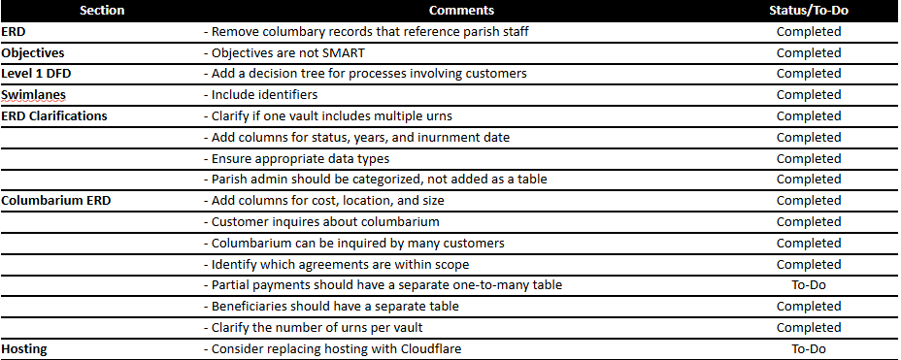

# I. Introduction

## 1.1 Project Context

St Alphonsus Mary de Liguori Parish is a Catholic church located in Humabon Place, barangay Magallanes, Makati, Philippines. They offer a variety of services such as funerals, weddings, and columbarium services. It was originated by the Roman Catholic Archdiocese of Manila and was established on August 2, 1967. The Roman Catholic Archdiocese of Manila is one of the oldest and most prominent Catholic jurisdictions in the Philippines. Established on February 6, 1579, by Pope Gregory XIII, it serves as the metropolitan see for the ecclesiastical province of Manila.

The church’s establishment and relevance are still strong; however, a lot of its processes still use dated methods. With these methods and many customers, the process has room for human errors such as duplicated records, loss of records, wrong input information, miscommunication, and missing records. This leads to the use of modern methods such as the utilization of technology to automate their processes and aid them in their accommodation of the customers.

To address these issues, the study aims to design and implement a modern, user-friendly system to automate and streamline these processes. The developers will bridge the church's gap in modern technology knowledge by creating a system that simplifies operations for the benefit of both the church staff and its customers.

## 1.2 Statement of the Problem

1. **Difficulty keeping track of available columbaries leading to a duplication of records, customer payment status, and contract validity.**
2. **Outdated and inefficient retrieval of vault information.**
3. **The parish lacks a facility to store customer and vault information**

## 1.3 Objectives

To answer the identified problems, the project aims to design a customized local web application. To be specific, this project aims to:

1. **Develop a local web application to manage, available columbaries, customer transactions, and other relevant documents with 99% accuracy.**
2. **Create a secure customer portal with retrieval of vault information with a 3-second data access, and multi-factor authentication.**
3. **Implement automated daily backups with 100% success rate, and a 30-minute restoration time.**

## 1.4 Significance of the Project

The Chambers of the Burning Ashes System (CBAS) is significant for its potential to modernize and improve the outdated and inefficient system at St. Alphonsus Mary de Liguori Parish, thereby reducing human errors and improving operational efficiency. By transitioning from manual record-keeping to a centralized, secure, and automated document management system, the church can ensure accurate tracking of columbaries, safeguard customer data, and provide better service to its community.

1. **St. Alphonsus Mary de Liguori Parish employees.** By implementing a document management system, employees will benefit from a streamlined workflow, reducing the time and effort required to manage columbarium records. This system will enable employees to accurately add, remove, and track columbaries, effectively eliminating issues like duplicate sales and lost records. The inclusion of automated data backup and encryption will ensure that records are secure and easily recoverable, mitigating risks associated with human error and data loss.

1. **Customers.** The implementation of a secure and automated document management system ensures that their data is handled with the utmost care, significantly reducing the risk of errors, loss, or miscommunication. In addition, the improved tracking of payment statuses will offer customers clear and accurate information about their transactions, fostering trust and satisfaction with the church's services.

## 1.5 Scope and Limitations

### 1.5.1 Scope

The research is limited to the creation and implementation of the new system. The system will be making use of MySQL as the main organization storage system and Nextcloud as the backup organization storage system. Focusing on cloud storage, it does not include services irrelevant to the system’s design. The system will feature a user-friendly interface capable of catering to beginners in IT using the Django framework, an integrated cloud database backup storage through Nextcloud, an Optimal Character Recognition for data transferring, report generation for sales and availability of the columbaries, and analytics that utilizes machine learning. As the system will have analytics, it will also be making use of the relevant Python libraries for machine learning. Libraries like matplotlib will be heavily used for the analytics.

### 1.5.2 Limitations

As the system will make use of Django, it will not be using other frameworks such as Laravel and CodeIgniter. The system does not cover other areas and services of the Parish aside from those related to the columbary services. Examples are the following: wedding services, funerary services, etc. Furthermore, the system will only be sought to improve on the current manual services and will not be in the online space.

# II. Data Flow Diagram

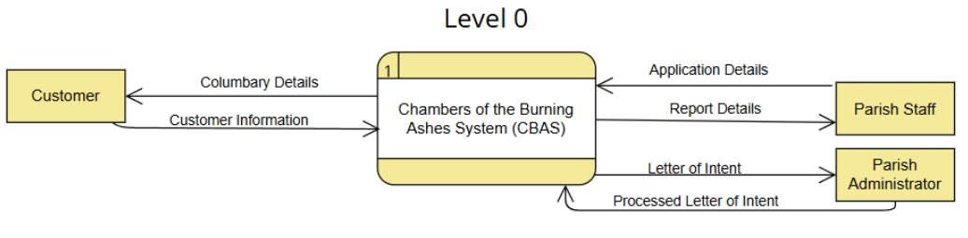

Figure 1: Level 0 Data Flow Diagram

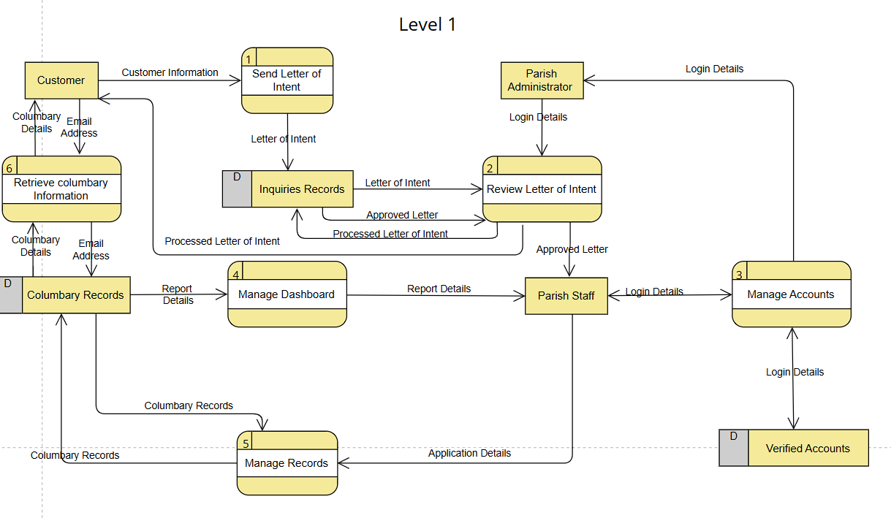

Figure 2: Level 1 Data Flow Diagram

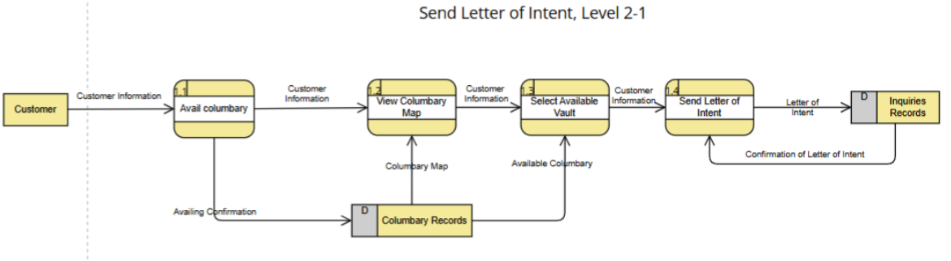

Figure 3: Level 2-1, Send Letter of Intent

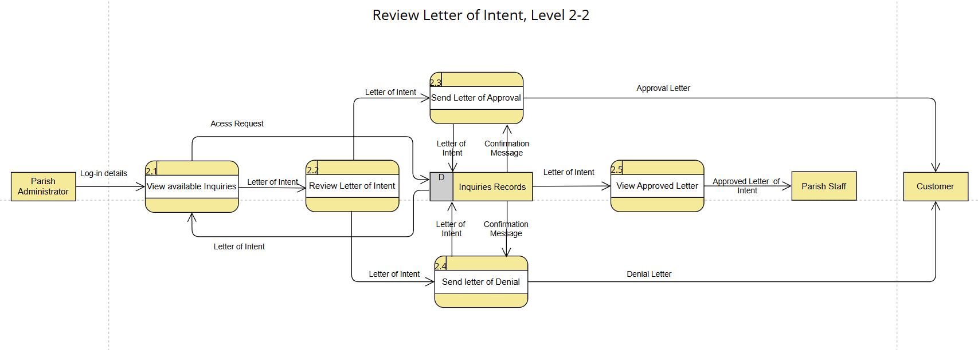

Figure 4: Level 2-2, Review Letter of Intent

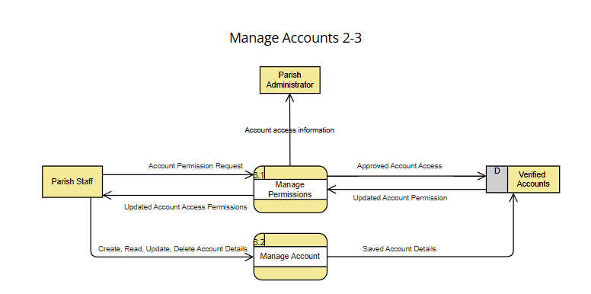

Figure 5: Level 2-3, Manage Accounts

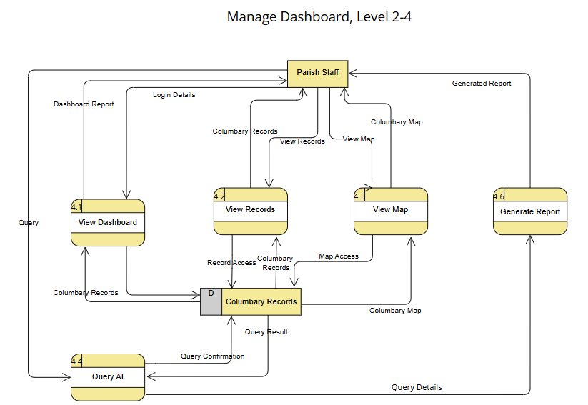

Figure 6: Level 2-4, Manage Dashboard

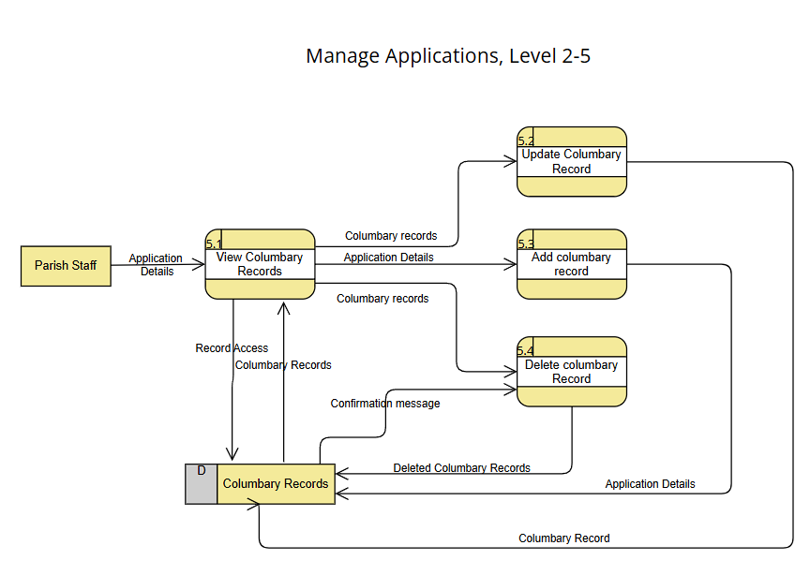

Figure 7: Level 2-5, Manage Applications

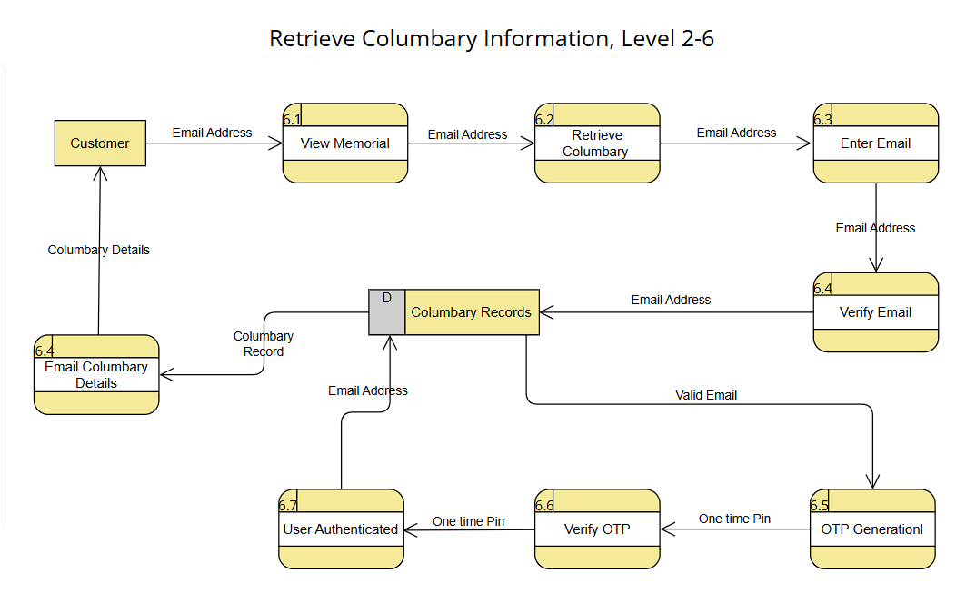

Figure 8: Level 2-6, Retrieve Columbary Information

# III. Use Case Diagram

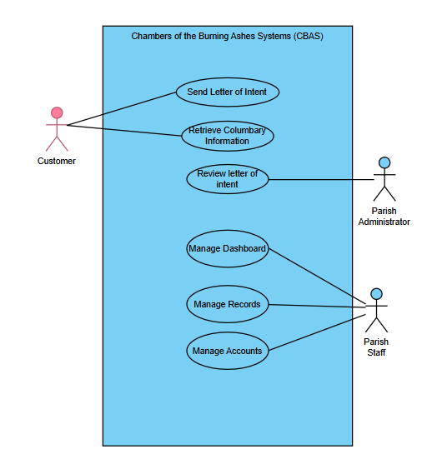

Figure 9: Use Case Diagram

## 3.1 Use Classes and Characteristics

Table 2: Roles & Description

|  |  |
| --- | --- |
| Roles | Description |
| *Parish Office Staff* | *The main user of the new system that is being*  *developed* |
| *Parish Administrator* | *The one who oversees the management of*  *columbaries and check them sometimes.* |
| *Customer* | *The possible consumers of the columbary*  *services offered by the Parish* |

## 3.2 Fully Dressed Use Cases

Table 3: Send Letter of Intent

|  |  |
| --- | --- |
| Use Case Name | Send letter of intent |
| Use Case Number | UC-01 |
| Actors | Customer, Parish Administrator |
| Description | This use case presents how the customer sends the letter of intent to the parish. |
| Pre-Conditions | * The columbary map and pricing information are up to date. * The parish CBA systems are operational and accessible. * Customer wants to avail a columbary. |
| Post Conditions | * The customer successfully views available columbaries and their prices. * A letter of intent with the customer’s information is generated and sent via email to the parish administrator. |
| Main Scenario | 1. Customer visits the system. 2. Customer visits the virtual tour and looks for columbaries. 3. Customer views the pricing and sections of each columbary. 4. Customer goes back to the main home page and clicks the “avail now” button. 5. Terms & conditions will appear before proceeding. 6. Customer reads the terms & conditions 7. Customer fills in customer information such as email, Cellphone number, Name, and address 8. Customer clicks on the “send” button to send a letter of intent to the Parish. |

Table 4: Retrieve Columbary Information

|  |  |
| --- | --- |
| Use Case Name | Retrieve Columbary Information |
| Use Case Number | UC-02 |
| Actors | Customer, Parish Staff |
| Description | This use case describes how the system retrieves information relevant to the customer. |
| Pre-Conditions | * The customer has previously applied for and purchased a columbary and provided a phone number and email address during the application process. * The customer has access to the internet and a valid email account. * The CBA system website is operational, and the customer’s columbary information is stored and accessible within the system. * Customer receives and inputs the correct one-time pin. |
| Post Conditions | * The customer successfully retrieves their columbary information via email, including any relevant documents. * The system logs the retrieval request and verification process for auditing purposes. * The system ensures that the customer’s information is securely transmitted and accessed. |
| Main Scenario | 1. Customers navigates to the retrieve columbary tab. 2. Customer clicks the retrieve information button. 3. Customer inputs their email address. 4. The system will generate an OTP and send it to the customer’s email. 5. Customer receives their OTP. 6. Customer inputs their OTP code into the website. 7. The customer receives an email containing minimal columbary information. |

Table 5: Review Letter of Intent

|  |  |
| --- | --- |
| Use Case Name | Review letter of intent |
| Use Case Number | UC-03 |
| Actors | Parish Administrator, Customer, Parish Staff |
| Description | This use case describes how the parish administrator reviews the letter of intent sent by the customer and decides either to approve or deny it. |
| Pre-Conditions | * The Parish Administrator logged in to the email they use for the CBA system. * A letter of intent has been sent by the customer. |
| Post Conditions | * The inquiry has been reviewed. * A decision has been made. * Customer Receives letter of approval/denial through email. * The approved letter of intent is sent to the Parish Staff. |
| Main Scenario | 1. The parish administrator opens their email for notifications regarding the letter of intent. 2. Parish administrator chooses a letter of intent 3. The parish administrator reviews the letter of intent. 4. The parish administrator approves the letter of intent. 5. The system sends a letter of approval to the customer’s email. 6. The system notifies and sends the approved letter of intent to the Parish Staff. |
| Alternate Scenario | 1. The parish administrator opens their email. 2. The parish administrator reviews the letter of intent. 3. The parish administrator denied the letter of intent. 4. The system sends a letter of denial to the customer’s email. |

Table 6: Manage Dashboard

|  |  |
| --- | --- |
| Use Case Name | Manage Dashboard |
| Use Case Number | UC-04 |
| Actors | Parish Staff |
| Description | This use case describes how the parish staff views necessary customer and columbary information and how they manage the CBA systems dashboard and AI assistant. |
| Pre-Conditions | * The parish staff is logged into the CBA system. * The CBA system is fully operational. * All records are viewable. * Columbary information is viewable. * CBA system AI assistant is functional. |
| Post Conditions | * PA |
| Main Scenario | 1. Parish Staff logs in to the system 2. Parish views the dashboard 3. Parish Staff views the columbary map 4. Parish Staff can view the available columbaries 5. Parish Staff navigates to the AI assistant chatbot 6. Parish staff inputs his prompt 7. Ai assistant answers the query. |

Table 7: Manage Application

|  |  |
| --- | --- |
| Use Case Name | Manage Records |
| Use Case Number | UC-05 customer |
| Actors | Parish Staff |
| Description | This use case describes how the parish staff opens the CBA system to update, create and delete customer and columbary records. |
| Pre-Conditions | * The parish staff member has valid login credentials (username and password). * The CBA system is operational and accessible. * The parish staff’s access permissions are properly configured in the system. * Parish staff is Logged-in in the system |
| Post Conditions | * The parish staff perform their duties, including managing customer records. * The Parish staff can add, edit and delete records. * Parish staff can scan new applications |
| Main Scenario | 1. The parish staff logs in to the system 2. The parish staff has three options add, edit and delete 3. The parish staff clicks on the “add” button to add new records. 4. The parish staff clicks on an existing columbary record and clicks on edit. 5. The Parish staff opens an existing columbary record and clicks on delete. 6. The parish staff clicks on the “Save button” |

Table 8: Manage Accounts

|  |  |
| --- | --- |
| Use Case Name | Manage Accounts |
| Use Case Number | UC-06 |
| Actors | Parish Staff, Parish Administrator |
| Description | This use case describes how the parish staff manage parish accounts on the CBA system. |
| Pre-Conditions | * The parish staff is logged into the CBA system with the necessary permissions to manage accounts. * The parish staff has navigated to the main dashboard of the CBA system. * The parish admin can be granted permissions to the system |
| Post Conditions | * The parish staff deletes, updates, manages permissions or creates an account for the CBA system. |
| Main Scenario | 1. The parish staff navigates to the accounts tab. 2. The parish Staff can then create, update, manage permissions, and delete accounts through the CBA System. 3. Parish staff manage access permissions to the Parish Administrator. |

# IV. Test Cases

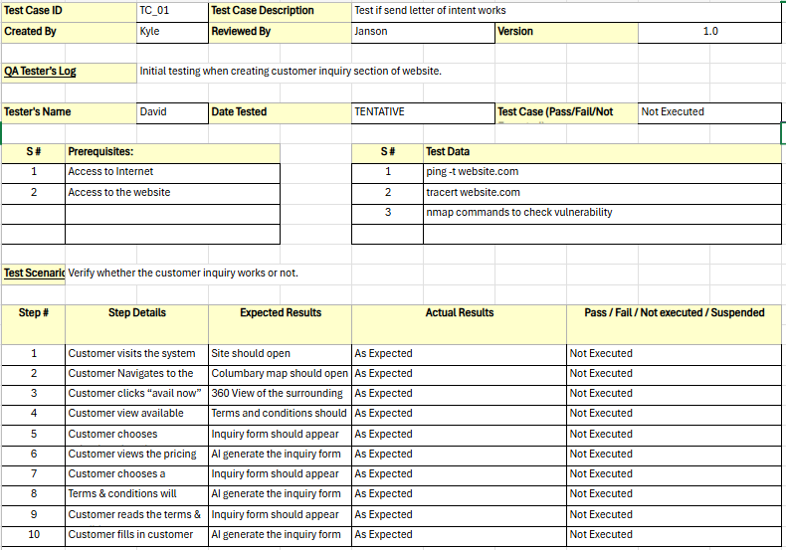

Figure 10: TC-01

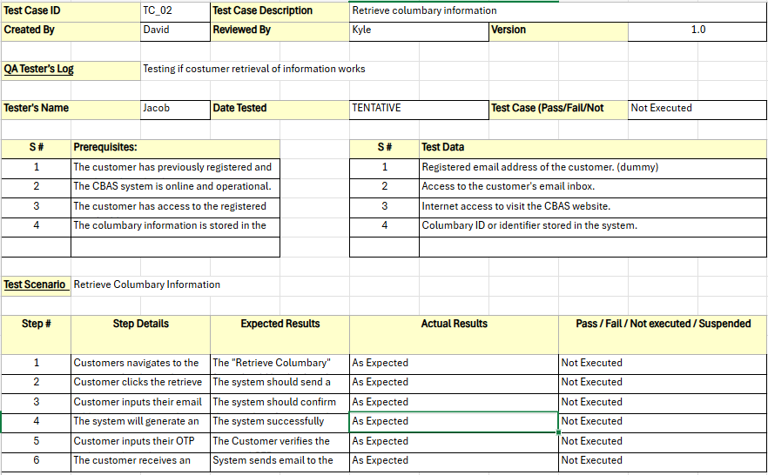

Figure 10: TC-02

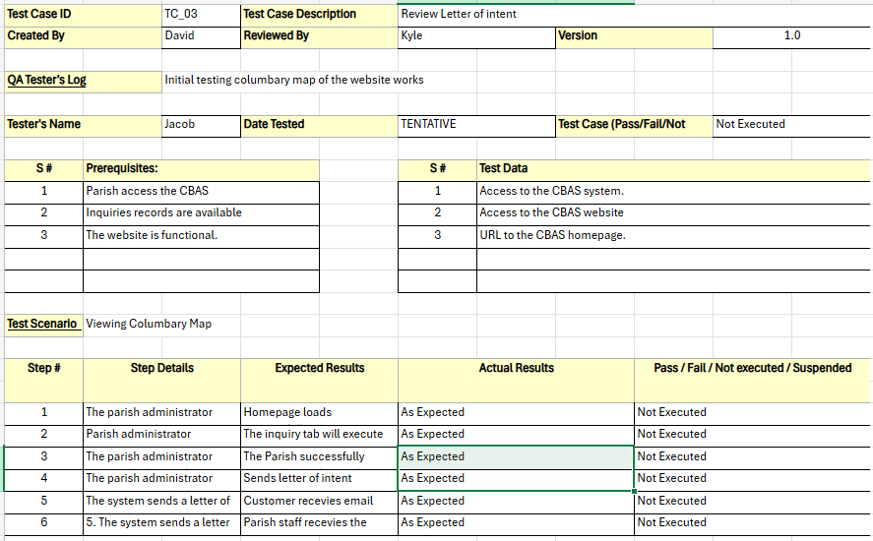

Figure 11: TC-03

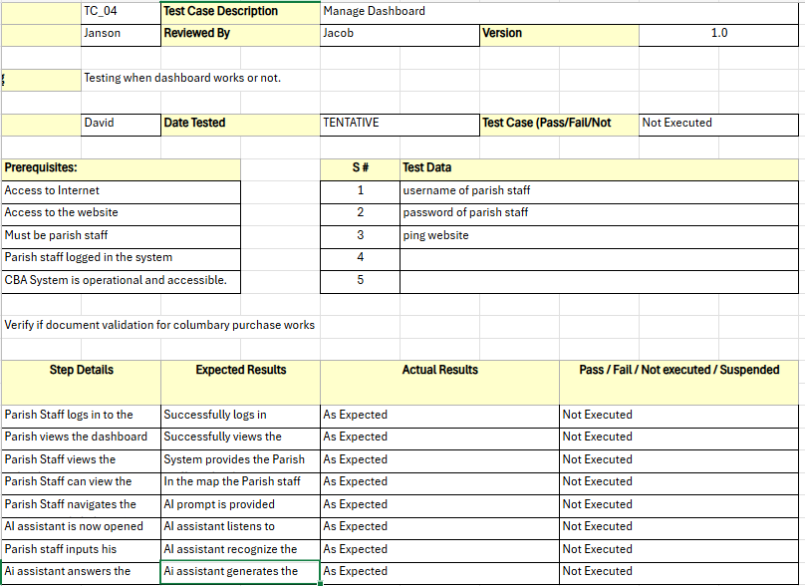

Figure 12: TC-04

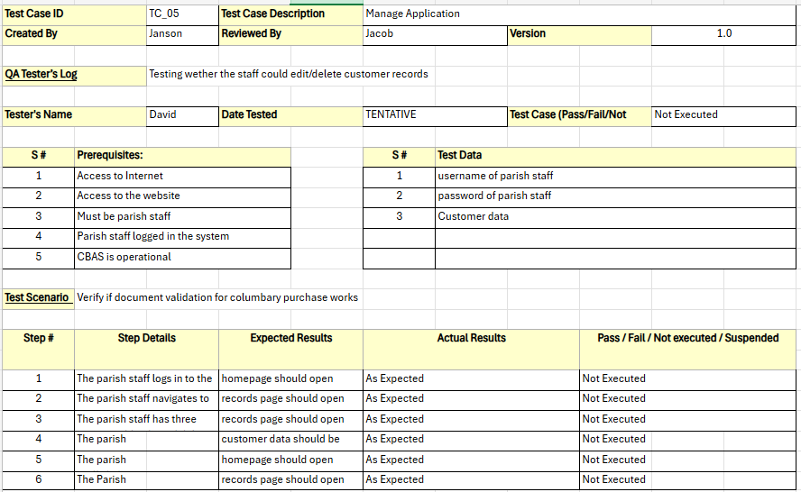

Figure 13: TC-05

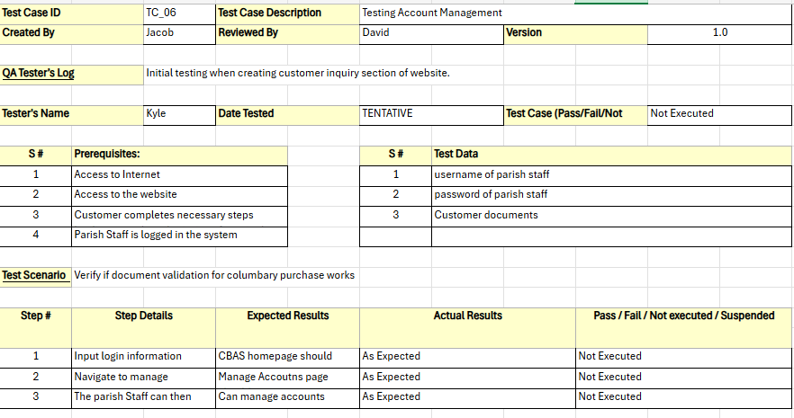

Figure 14: TC-06

# V. Activity Diagrams

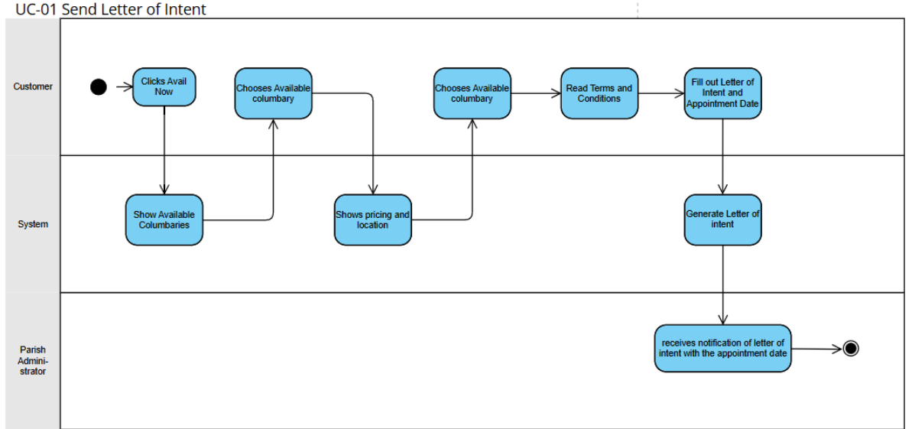

Figure 15: UC-01, Send Letter of Intent

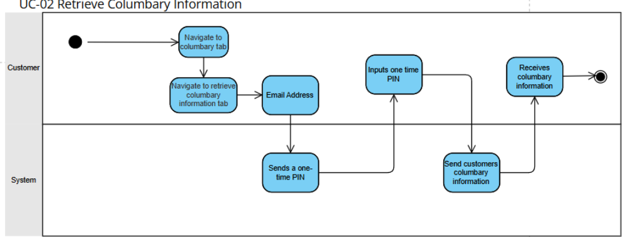

Figure 16: UC-02, Retrieve Columbary Information

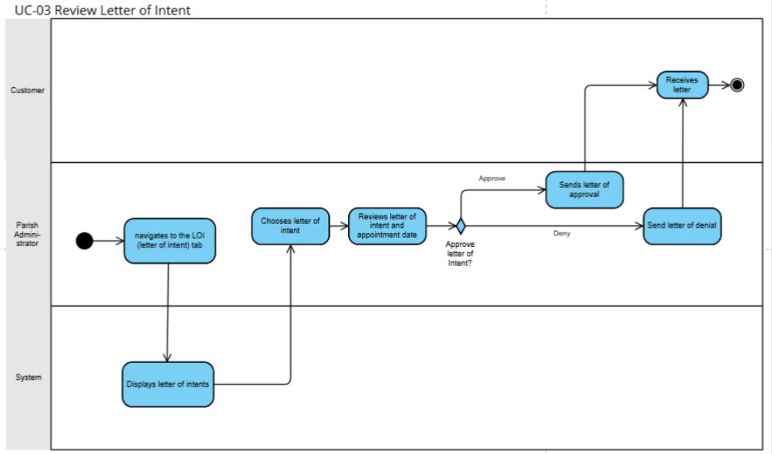

Figure 17: UC-03, Review Letter of Intent

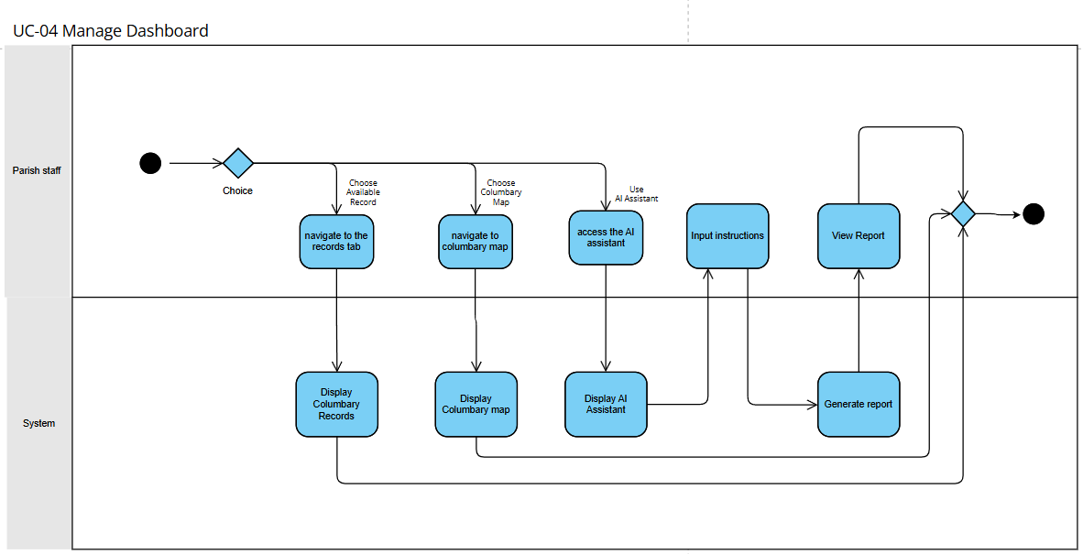

Figure 18: UC-04, Manage Dashboard

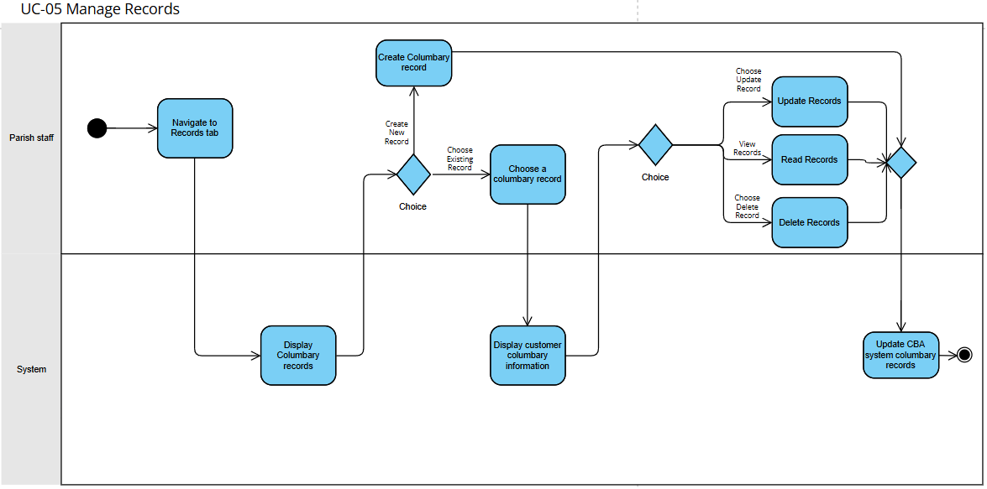

Figure 19: UC-05, Manage Records

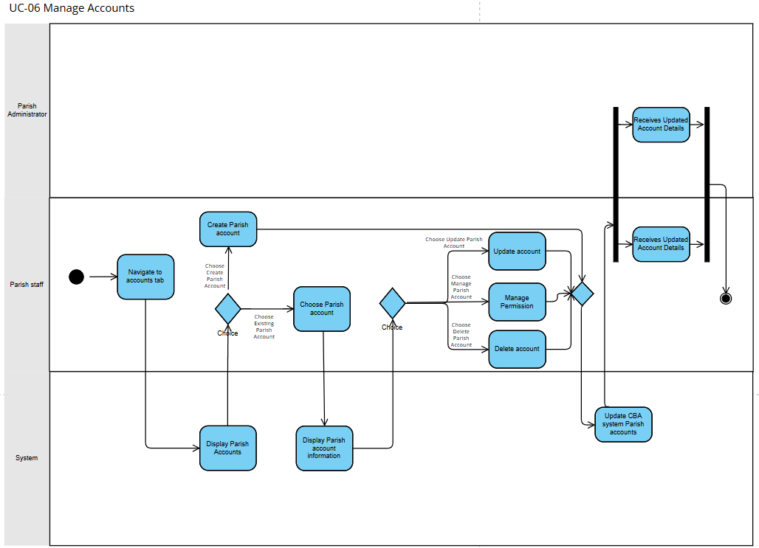Figure 20: UC-06 Manage Accounts

# VI. Database Design (Entity Relationship Diagram)

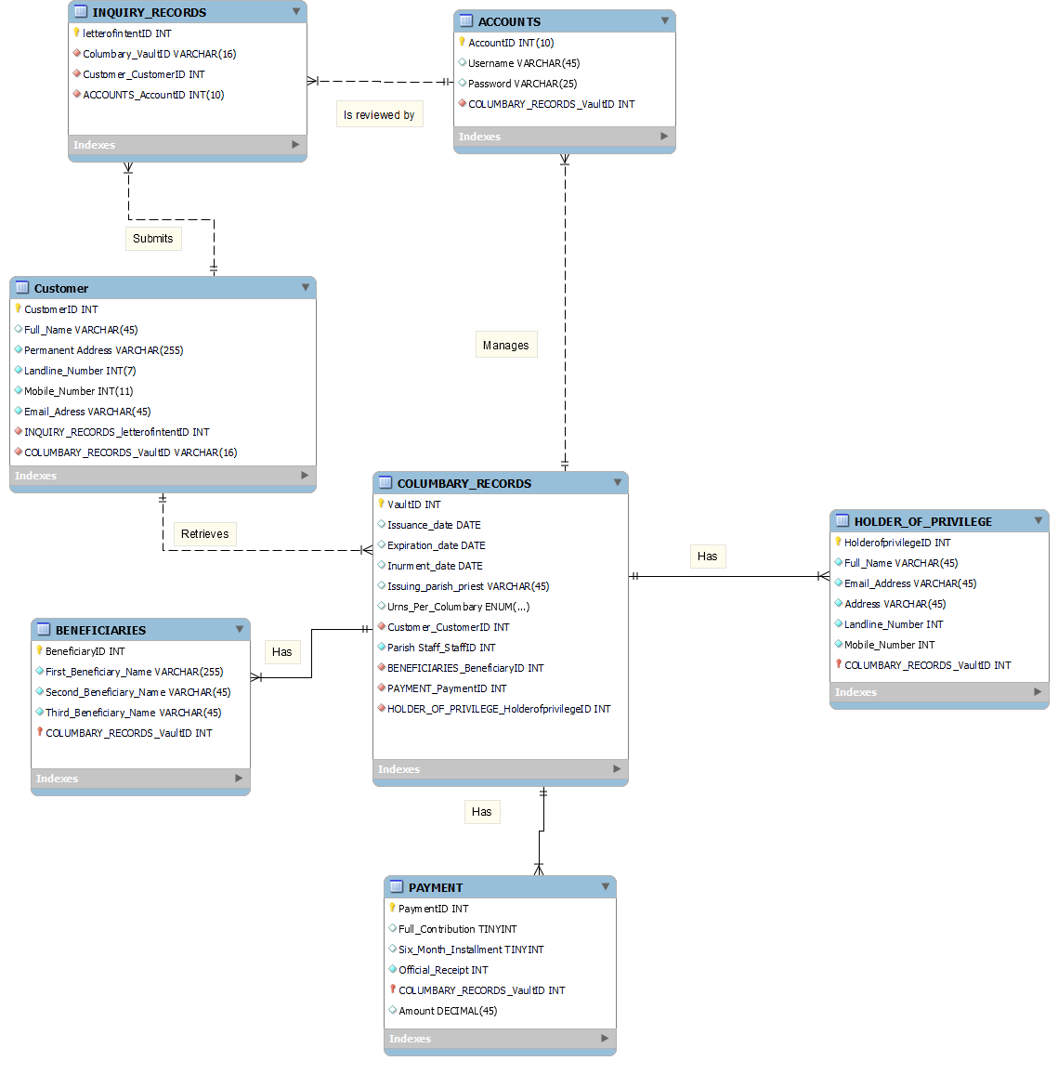

Figure 21: Entity Relationship Diagram

Table 9: Data Dictionary

|  |  |  |  |  |
| --- | --- | --- | --- | --- |
| TABLE NAME | ATTRIBUTE NAME | TYPE | PK OR FK | FK REFERENCED TABLE |
| Inquiry Records | Letter_Of_IntentID  Columbary_VaultID  Parish_Administrator_AdminID  Parish_Staff_StaffID  Customer_CustomerID | INT  VARCHAR  INT  INT  INT | PK  FK  FK  FK | Columbary_Records  Parish_Administrator  Parish_Staff  Customer |
| Customer | CustomerID  Full_Name  Permanent_Address  Landline_Number  Mobile_Number  Email_Address  Inquiry_Records_Letter_of_IntentID  Columbary_Records_VaultID | INT  VARCHAR  INT  INT  VARCHAR  VARCHAR  INT  INT | PK  FK  FK | Inquiry_Records  Columbary_Records |
| COLUMBARY_RECORDS | VaultID  Issuance_Date  Expiration_Date  Inurnment_Date  Issuing_parish_priest  Urns_Per_Columbary  Customer_CustomerID  Parish_Staff_StaffID  BENEFICIARIES_ BeneficiaryID  PAYMENT_ PaymentID  HOLDER_OF_PRIVILEGE_ HolderOfPrivilegeID | VARCHAR  DATE  DATE  DATE  VARCHAR  ENUM  INT  INT  INT  INT  INT | PK  FK  FK  FK  FK  FK | Customer  Parish_Staff  BENEFICIARIES  PAYMENT  HOLDER_OF_PRIVILEGE |
| ACCOUNTS | AccountID  Username  Password | INT  VARCHAR  VARCHAR | PK |  |
| PARISH_STAFF | StaffID  Accounts_AccountID | INT  INT | PK  FK | ACCOUNTS |
| PARISH_ADMINISTRATOR | AdminID  Accounts_AccountID | INT  INT | PK  FK | ACCOUNTS |
| HOLDER_OF_PRIVILEGE | HolderOfPrivilegeID  Full_Name  Email_Address  Address  Landline_Number  Mobile_Number  COLUMBARY_RECORDS_VaultID | INT  VARCHAR  VARCHAR  VARCHAR  INT  INT  INT | PK  FK | COLUMBARY_RECORDS |
| BENEFICIARIES | BeneficiaryID  First_Beneficiary_Name  Second_Beneficiary_Name  Third_Beneficiary_Name  COLUMBARY_RECORDS_VaultID | INT  VARCHAR  VARCHAR  VARCHAR  INT | PK  FK | COLUMBARY_RECORDS |
| PAYMENT | PaymentID  Full_Contribution  Six_Month_Installment  Official_Receipt  COLUMBARY_RECORDS_VaultID | INT  TINYINT  TINYINT  INT  INT | PK  FK | COLUMBARY_RECORDS |

# VII. Prototype

### 7.1 High Fidelity Prototype

The following high-fidelity prototype, developed by the proponents of CBAS, illustrates the fundamental design for authentication, the dashboard, and the user interface for customer records and available columbaries.

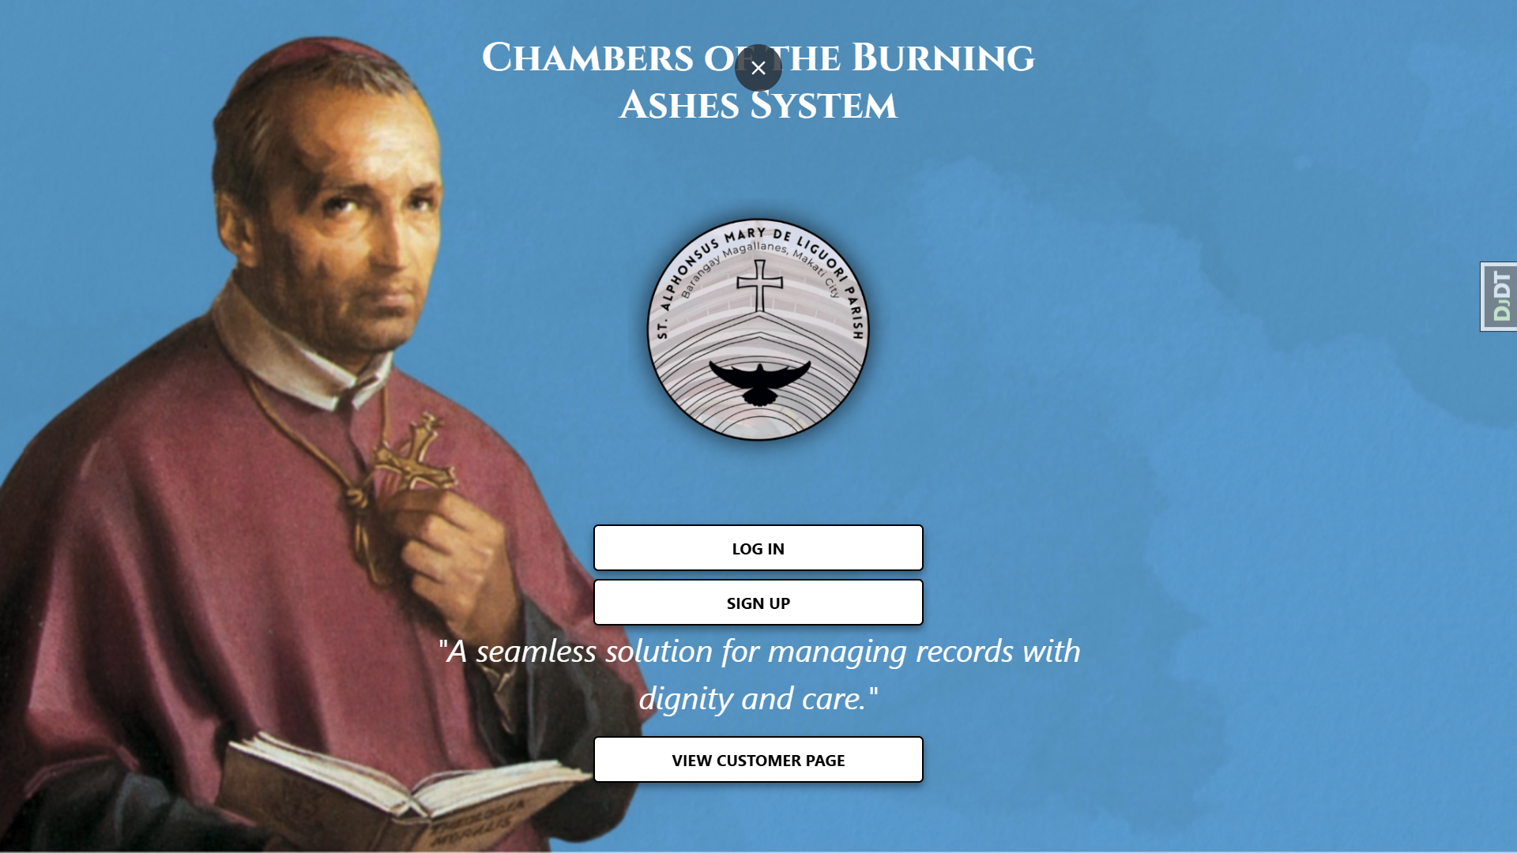

Figure 22: Authentication Page

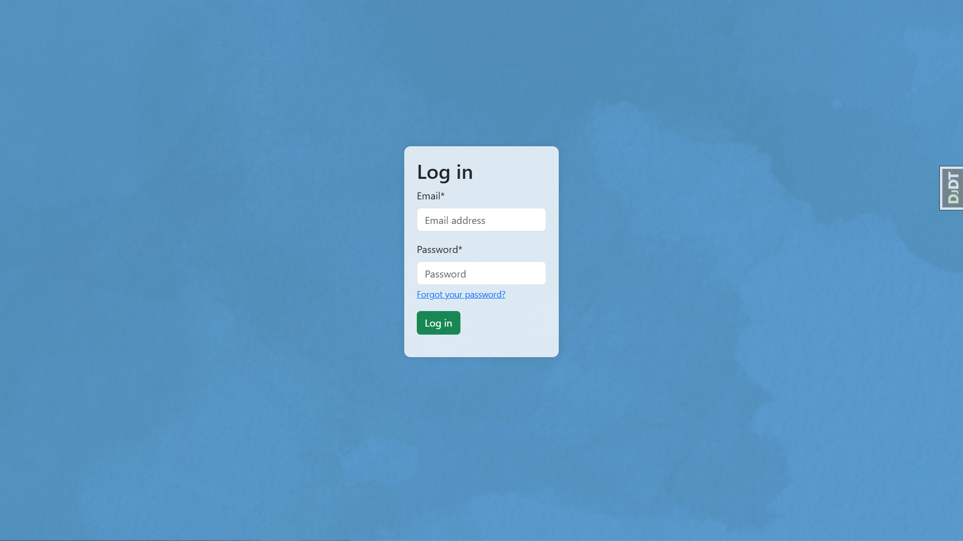

Figure 23: Login Page

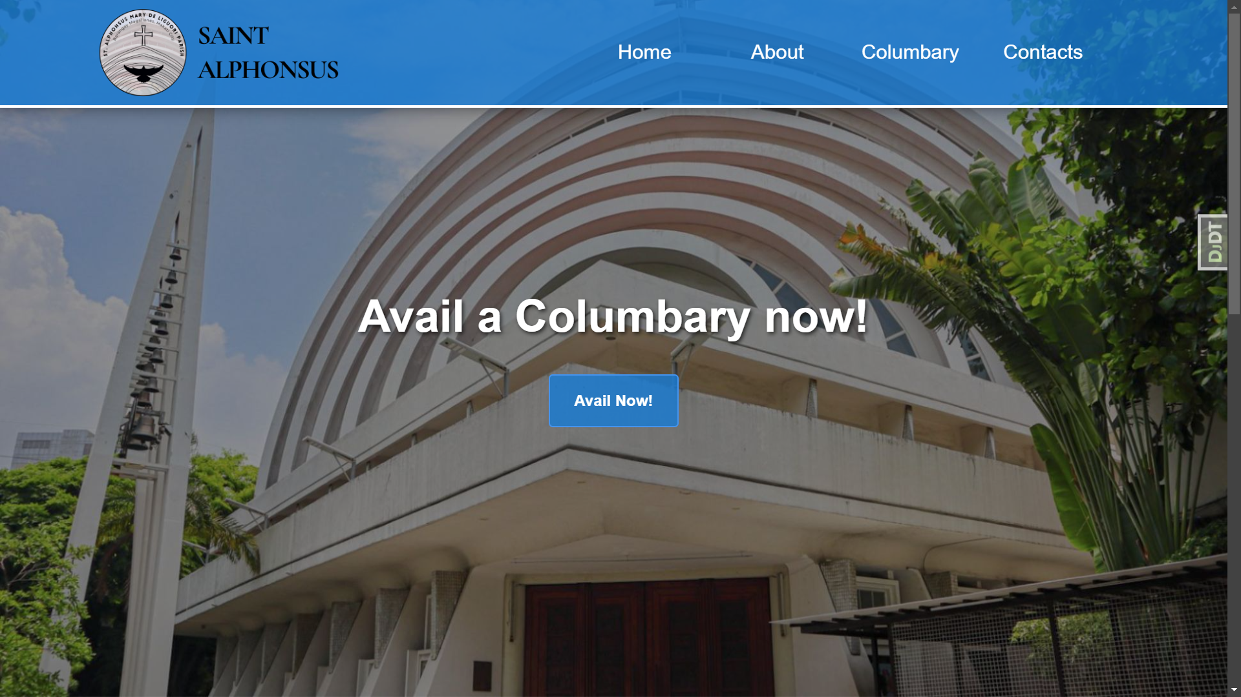

Figure 24: Home Page

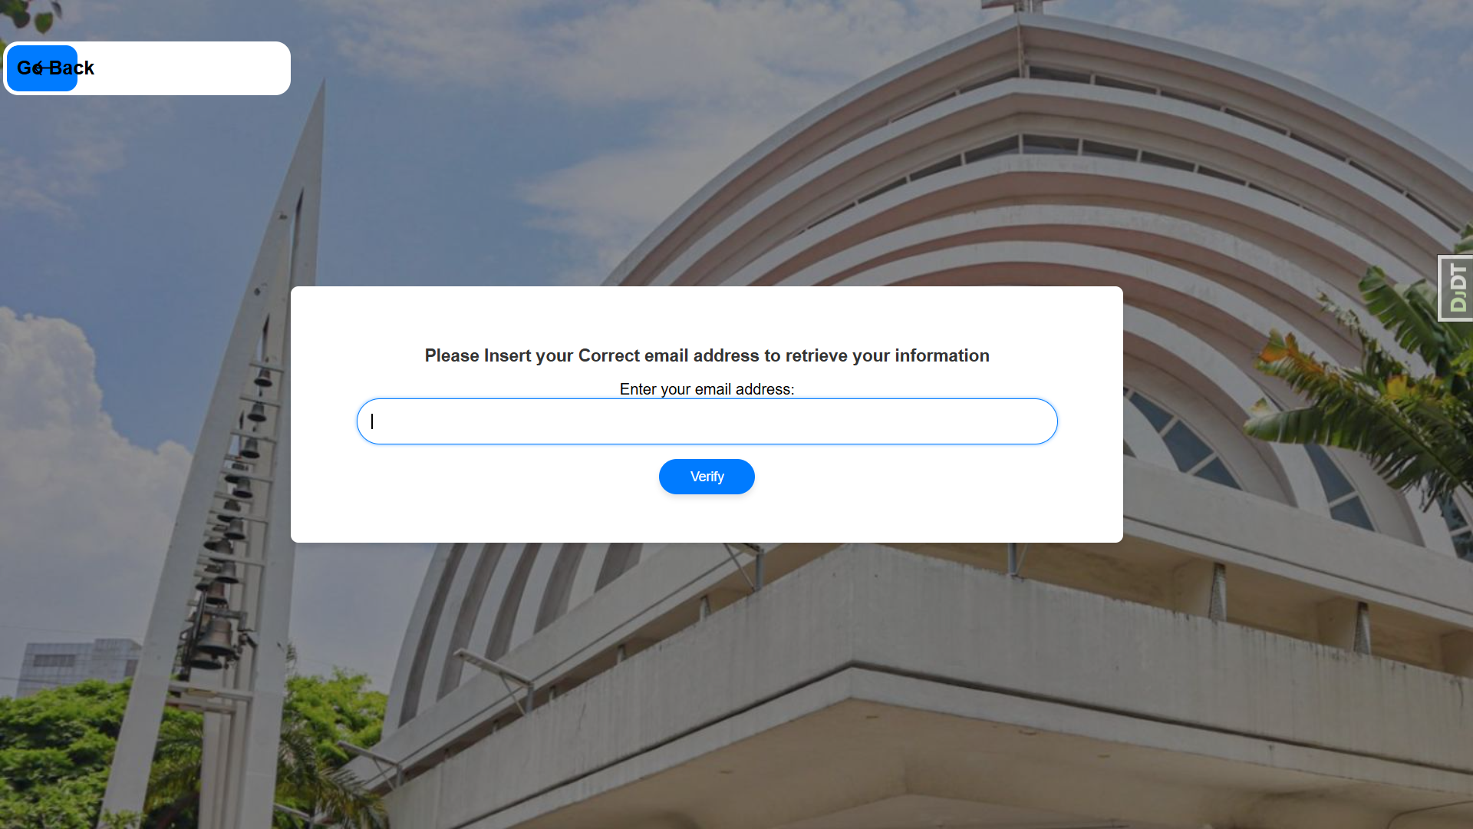

Figure 25: Record Page

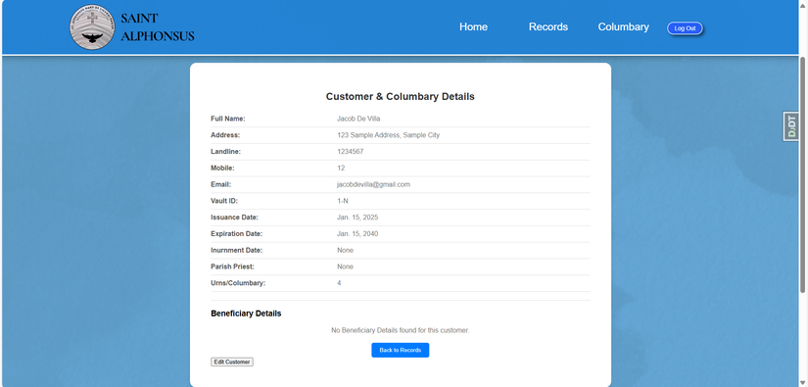

Figure 26: View Details

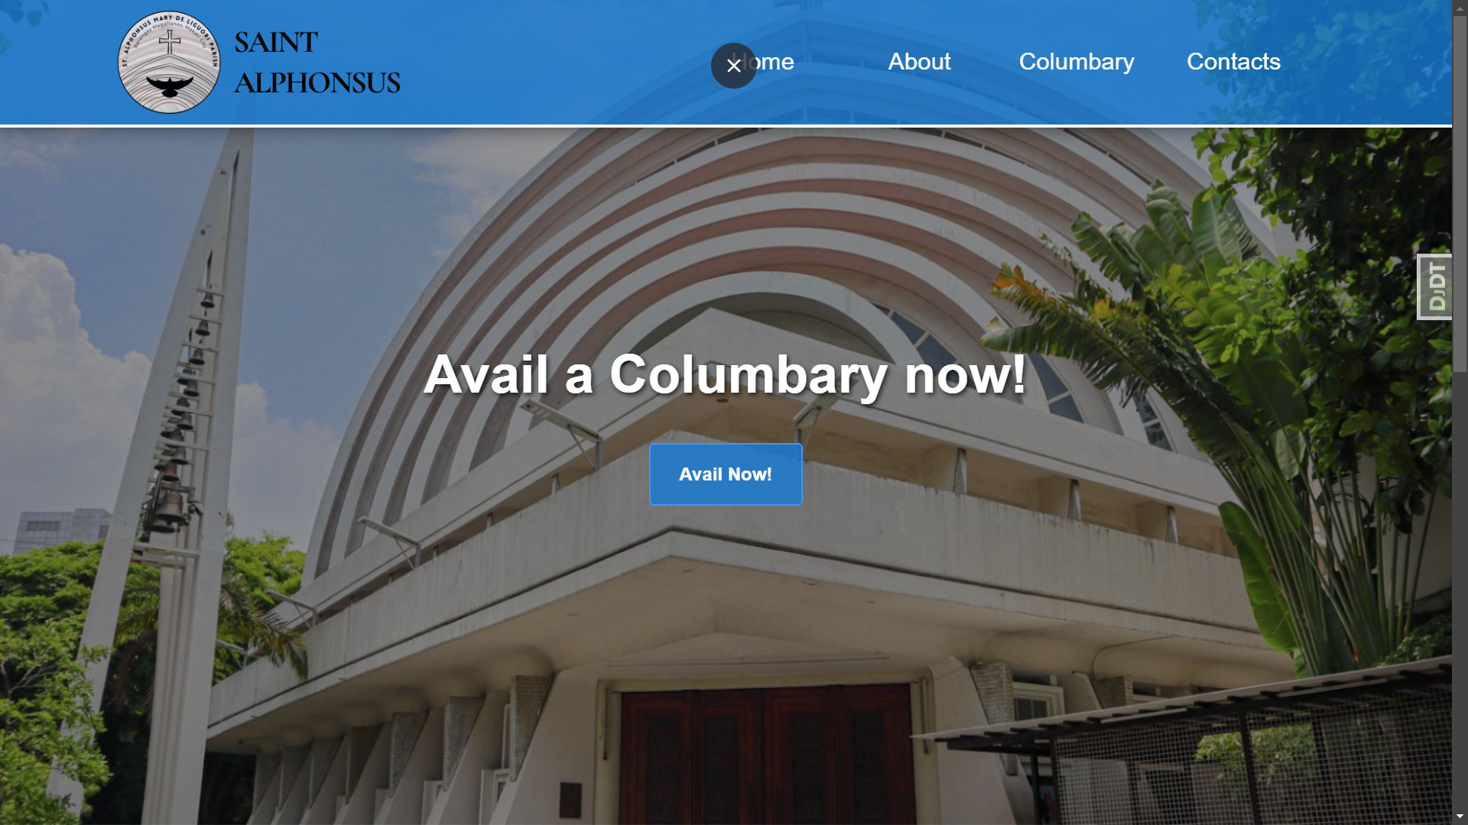

Figure 27: Customer Portal

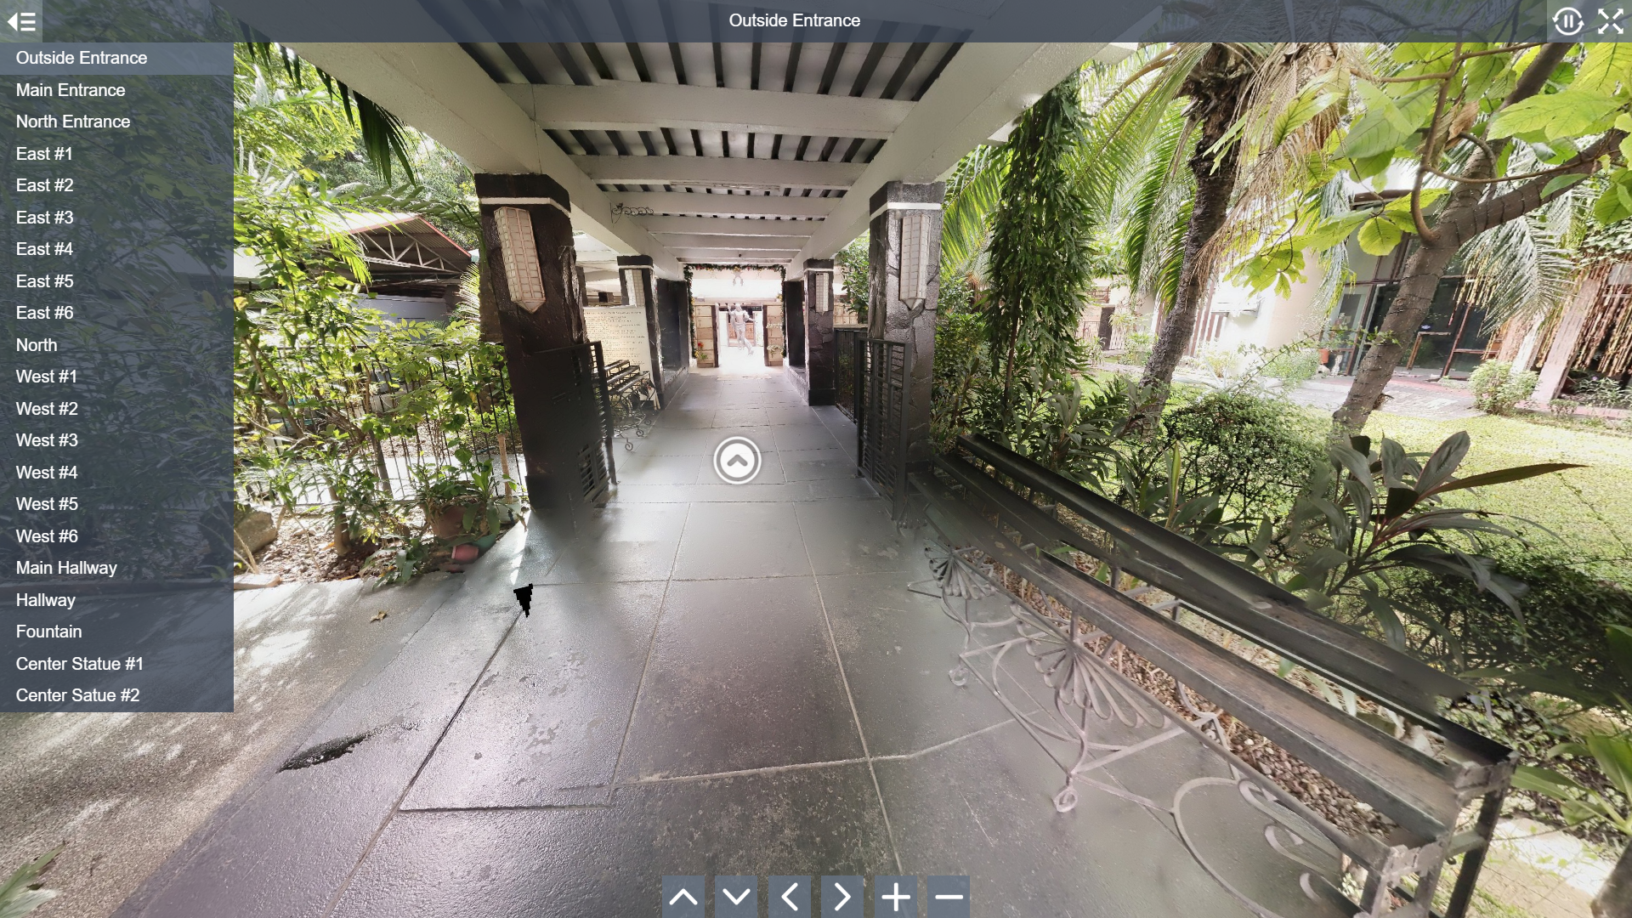

Figure 28: Virtual Tour

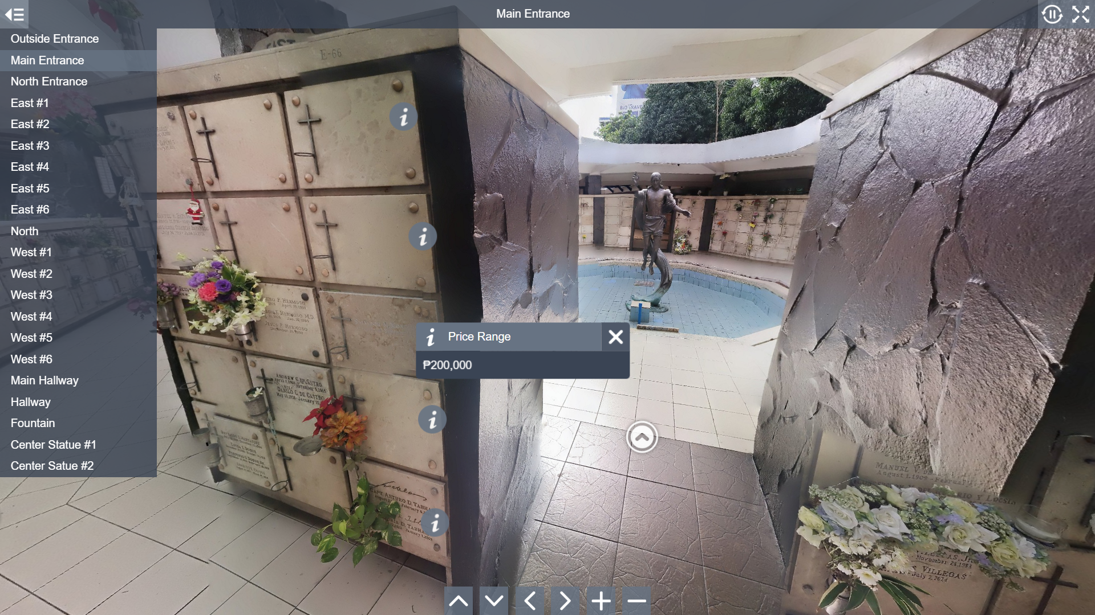

Figure 29: Price Range

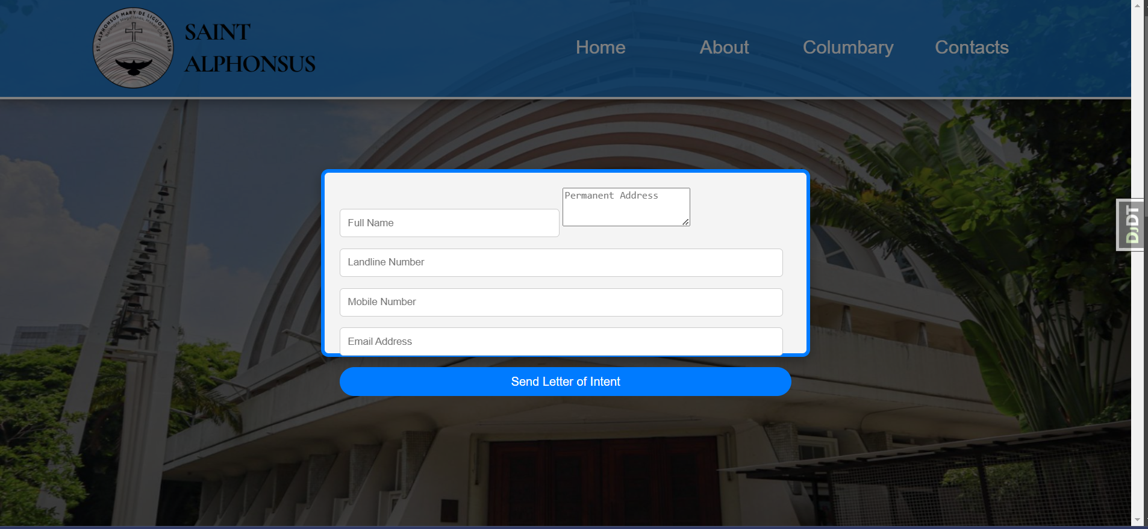

Figure 330: Send Letter of Intent

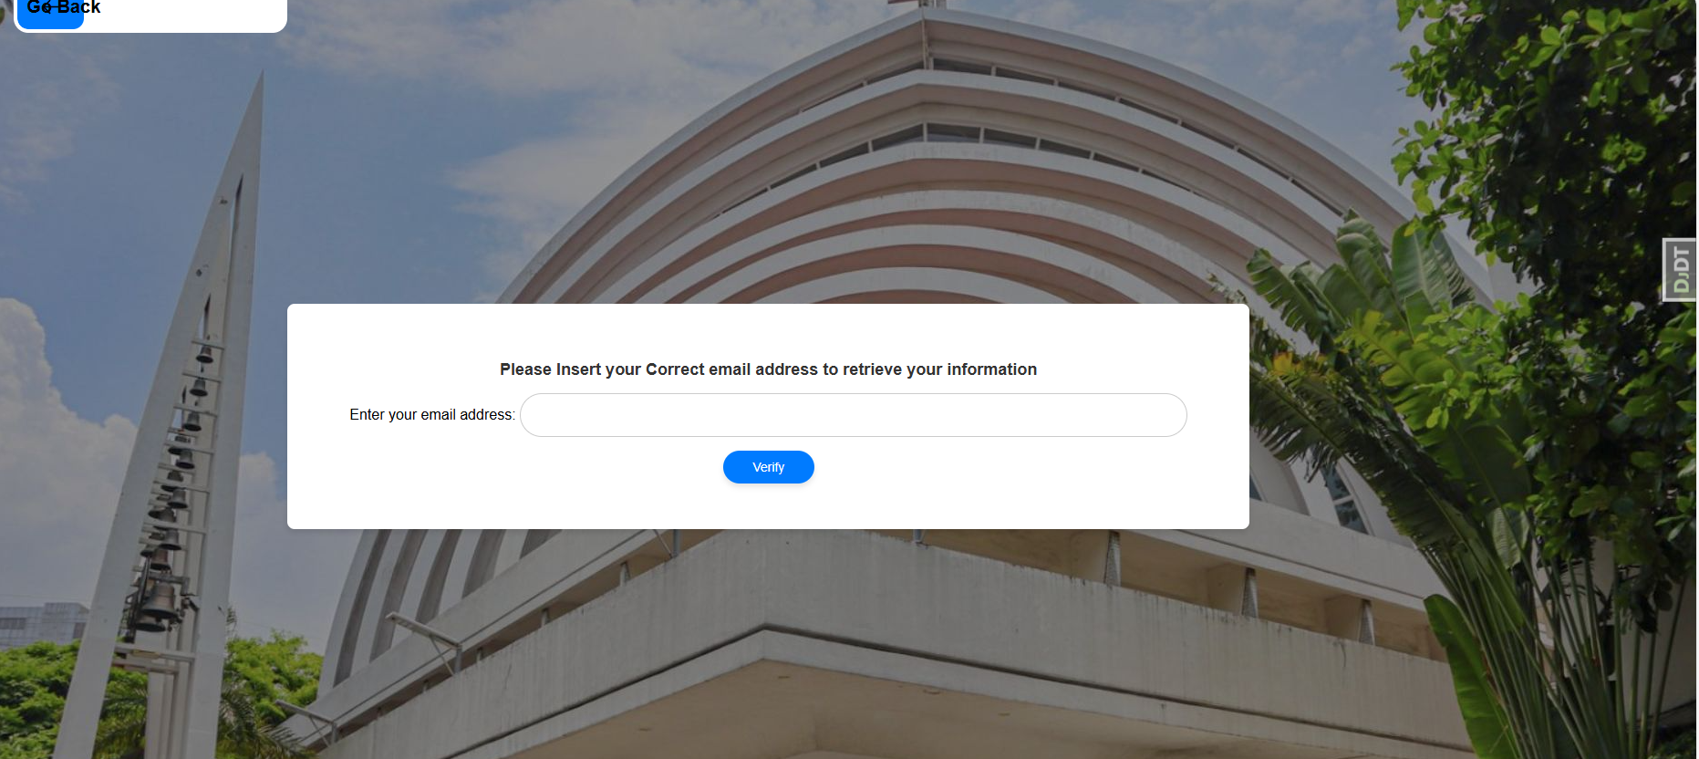

Figure 31: Retrieve Columbary

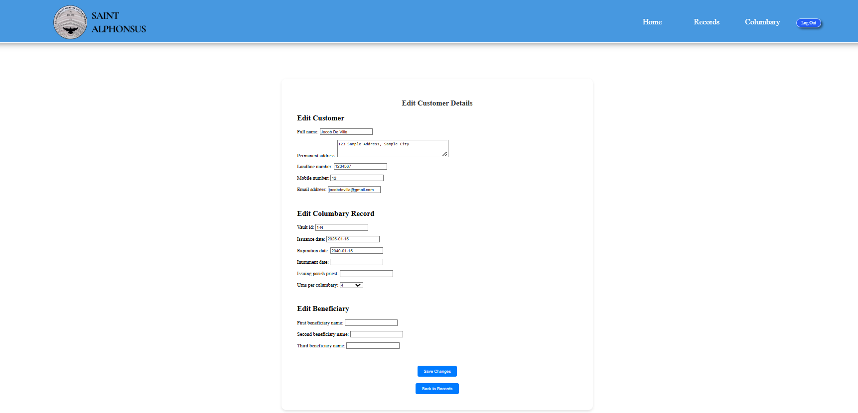

Figure 32: Edit Customer Details

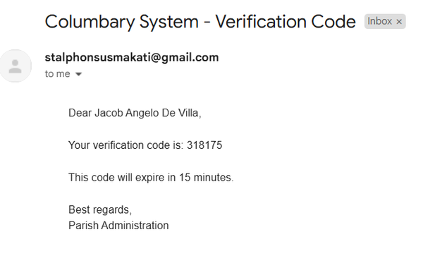

Figure 33: Verification Code

## 7.2 Technology Stack

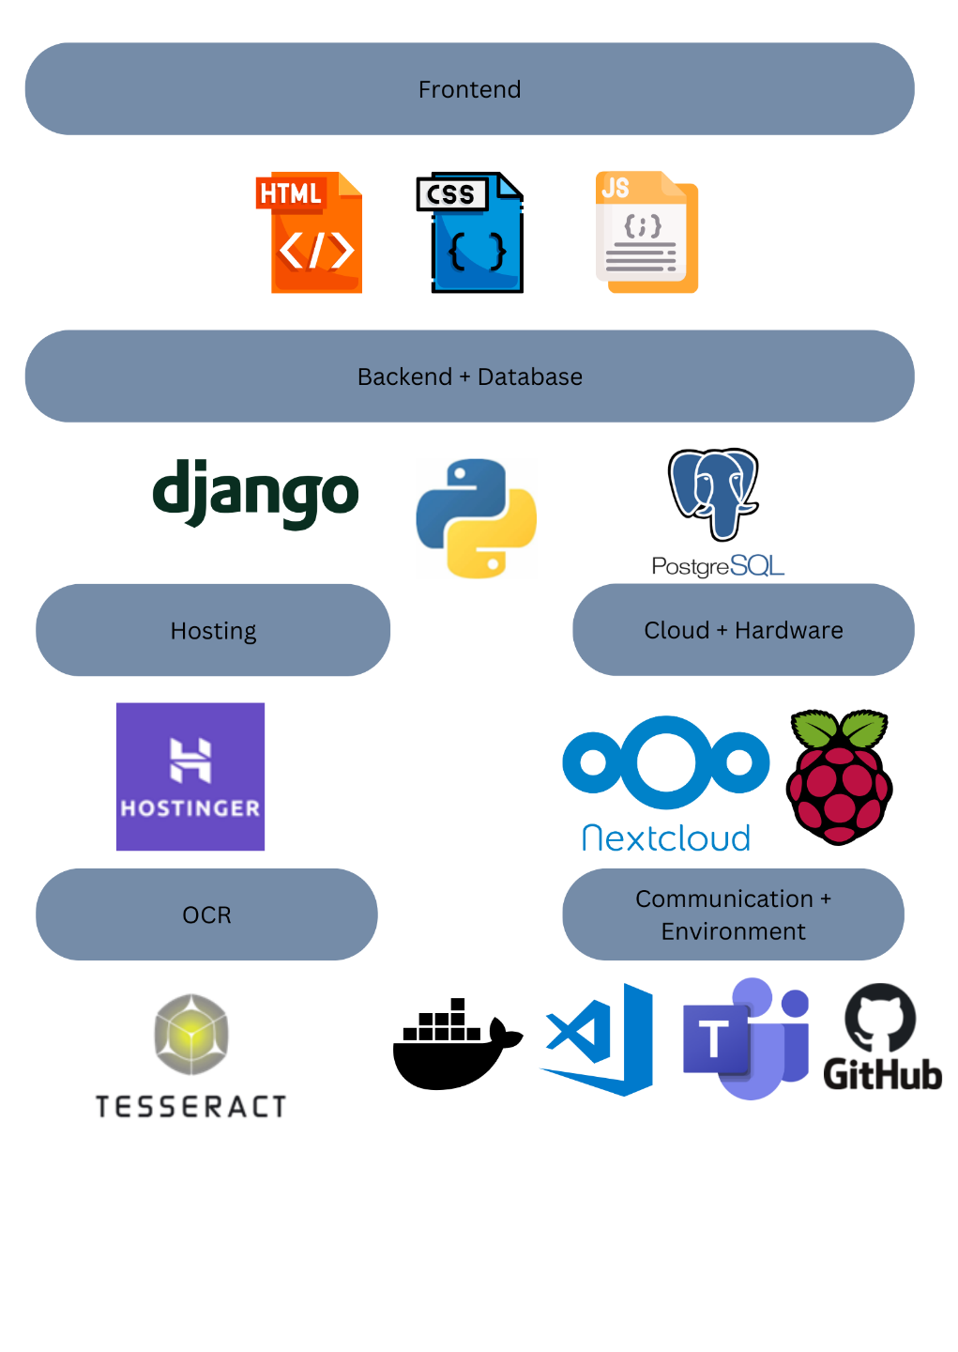

Figure 34: Technology Stack

## 7.3 Github Repository

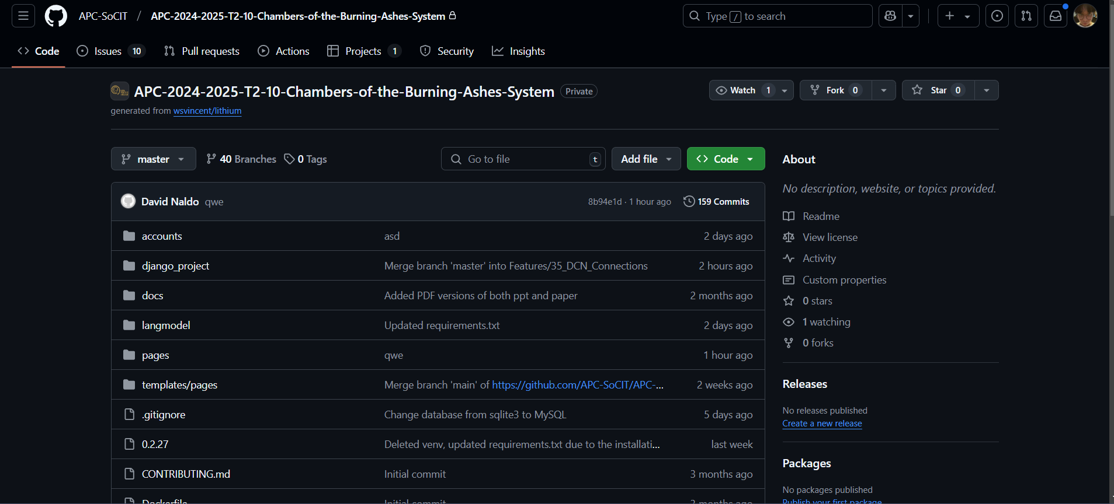

Figure 35: Github Repository

Official Phishda Chambers of the Burning Ashes System Github Repository, The repository can be accessed here: <https://github.com/APC-SoCIT/APC-2024-2025-T2-10-Chambers-of-the-Burning-Ashes-System.git>

# VIII. Appendices

## Appendix A: Project Vision

The vision for the Chambers of the Burning Ashes System (CBAS) is to revolutionize the management of columbarium services at St. Alphonsus Mary de Liguori Parish by implementing a modern, secure, and efficient web-based application. This system will streamline and automate the parish's current manual processes, significantly reducing errors and enhancing data security. By providing document management with robust backup and encryption capabilities,

CBAS will ensure accurate tracking of columbarium vaults, secure storage of customer data, and seamless retrieval of information. Ultimately, this project aims to improve operational efficiency, foster trust and satisfaction among customers, and empower parish staff with a user-friendly tool that simplifies their daily tasks.

Appendix B: Schedule/Release Plan

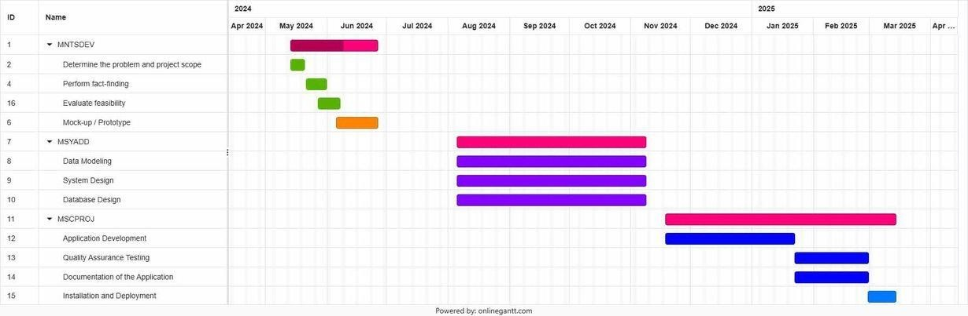

Figure 36: Log out Prompt

**Target Group**: St Alfonso’s Parish Columbarium

**Goal**: To digitize and create a document management system with the utilization of OCR and analytics.

**Needs**: To have a web-based platform.

**Value:** The new digitalized system will increase the security of the data due to its multiplatform capabilities and help the Parish locate certain data about columbaries without physically searching for it**.** Additionally, it aims to visualize data and generate reports.

**Key features**: Documentation Management System, AI Voice Assistant, Analytics, Nextcloud Pi.

**Release Plan**

Our release plan is divided into three sections according to our course subjects: MNTSDEV, MSYADD1, and MCSPROJ. The project is on schedule with the completion of Release 2, including this paper. The complete product backlog is available in Table 16.

Release 1

* Research paper
* Presentation deck
* Low-fidelity prototype

Release 2

* Model diagrams
* System design
* High-fidelity prototype

Release 3

* Functional prototype
* Deployed systems
* Quality assurance testing

## Appendix C: Product Roadmap

Table 10: Product Roadmap

|  |  |  |
| --- | --- | --- |
| **MNSTDEV** | **MSYADD** | **MCSPROJ** |
| **Inception**   * Client Search * Ideation   **Planning**   * Identify the problem/scope * Evaluate Feasibility   **Meeting**   * Meeting with the client * Process Immersion     **Low-Fidelity Prototyping**   * Create wireframe * Conceptualize use process flow     **Proposal**   * Presentation Deck * Documentation Paper | **Modeling**   * Data Flow Diagrams * Entity-relationship Diagrams * Improvement of Use Case Diagram * Sequence Diagrams * State Machine Diagrams * Package Diagrams   **Design**   * System Design * Database Design   **High-fidelity Prototyping**   * Figma Model * Responsive Design   **Construction Plan**   * Repository Generation * Drafting of   Documentation Plan   * Module Assignment * Team Training | **Development**   * Functional Prototype * Documentation   **Testing**   * Quality Assurance * Client Assessment **Internal Deployment** * Installation * Integration   **External Deployment**   * User-facing website * Payment Gateway |

## Appendix D: Teams Meetings

Date: 05/10/2024

Agenda: Onsite Meeting with client & visiting the Phishda team office

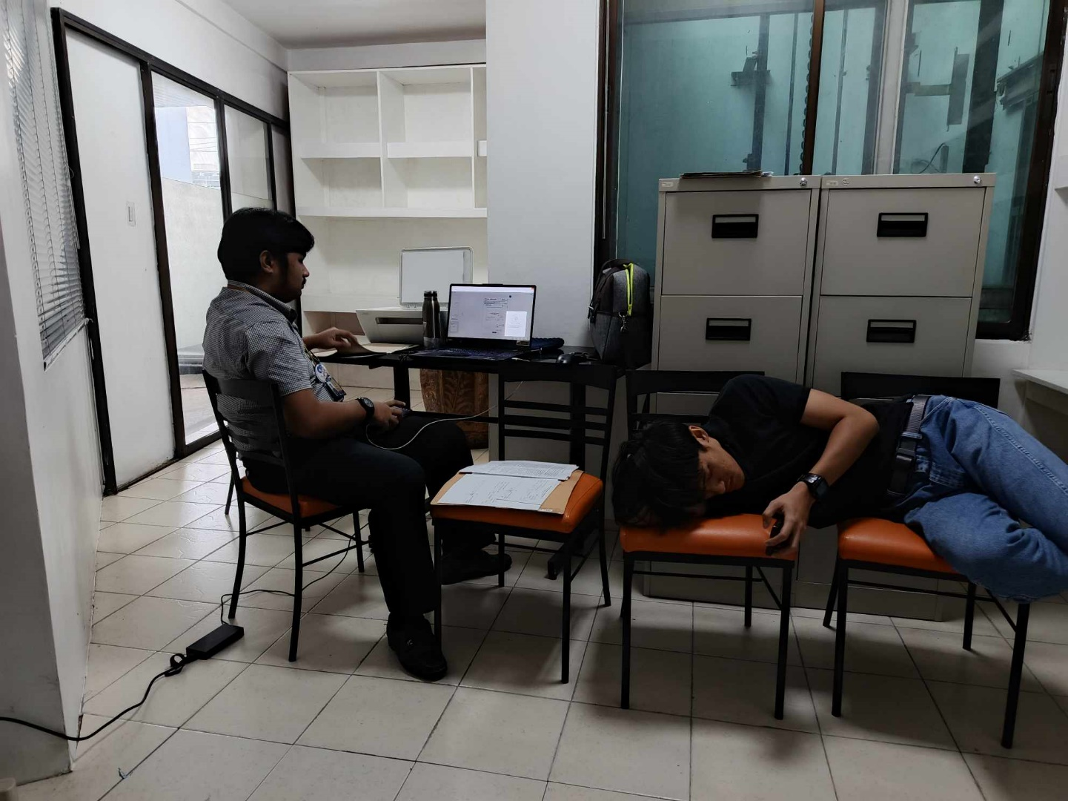

Figure 37: Onsite Meeting with Client

Date: 25/10/2024

Agenda: Group meeting

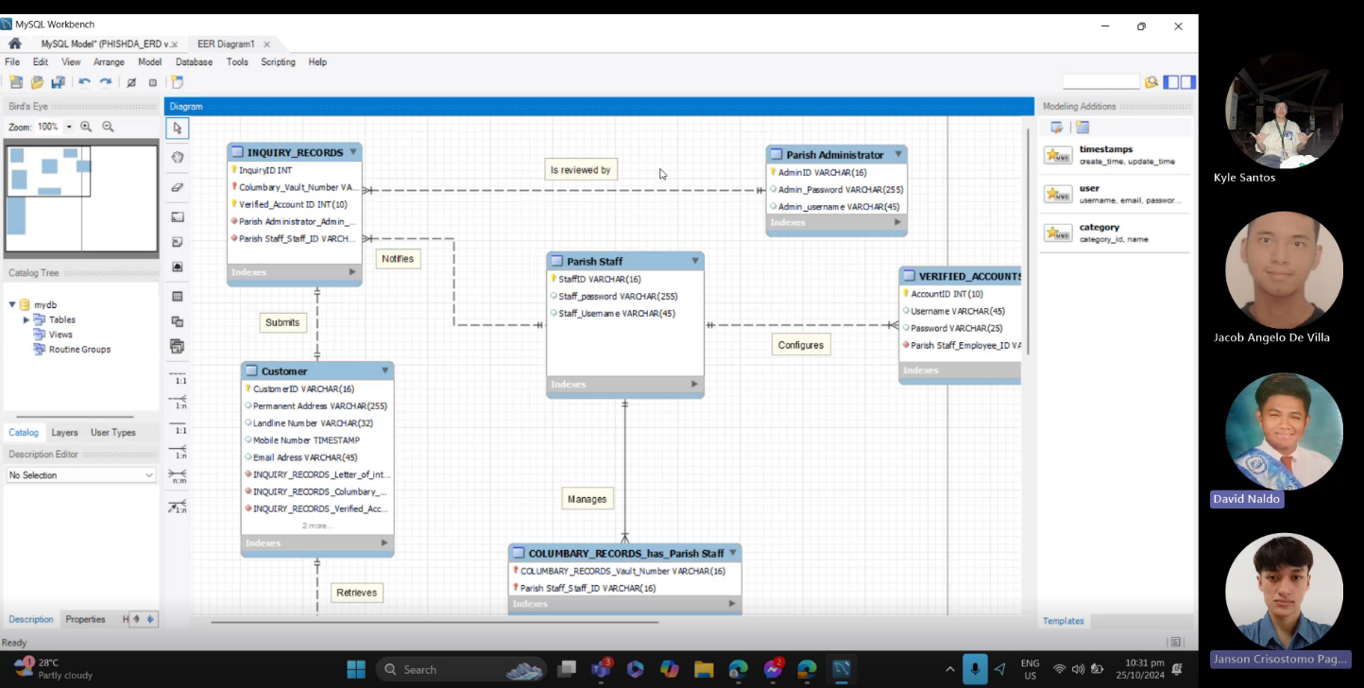

Figure 38: ERD Discussion Meeting

Date: 28/10/2024

Agenda: Group meeting

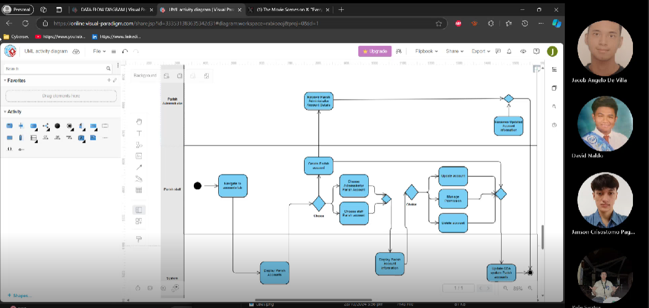

Figure 39: Activity Diagram Discussion Meeting

Date: 24/10/2024

Agenda: Meeting with consultant.

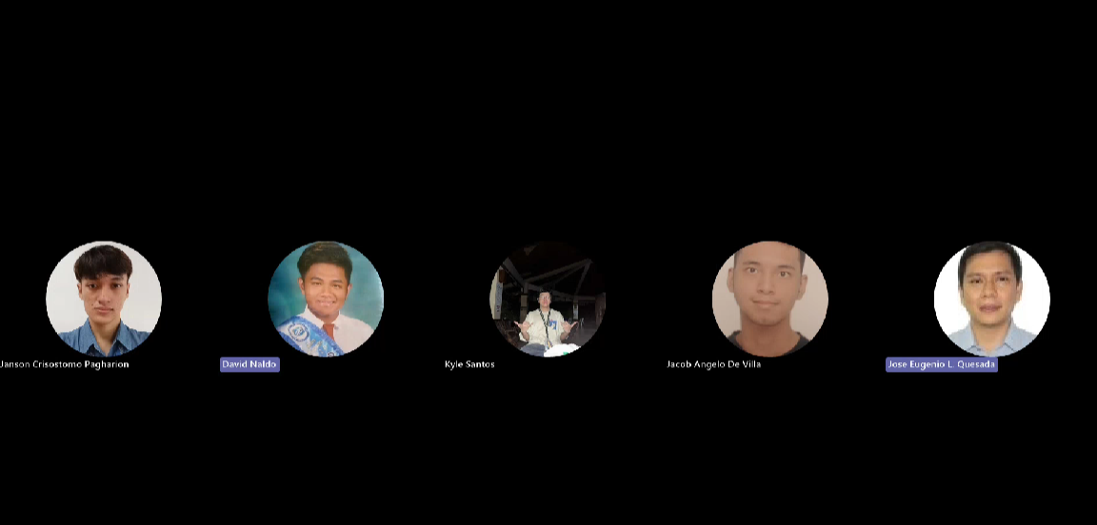

Figure 40: Consultant Meeting

Date: 28/10/2024

Agenda: Final Meeting Before Finals Defense.

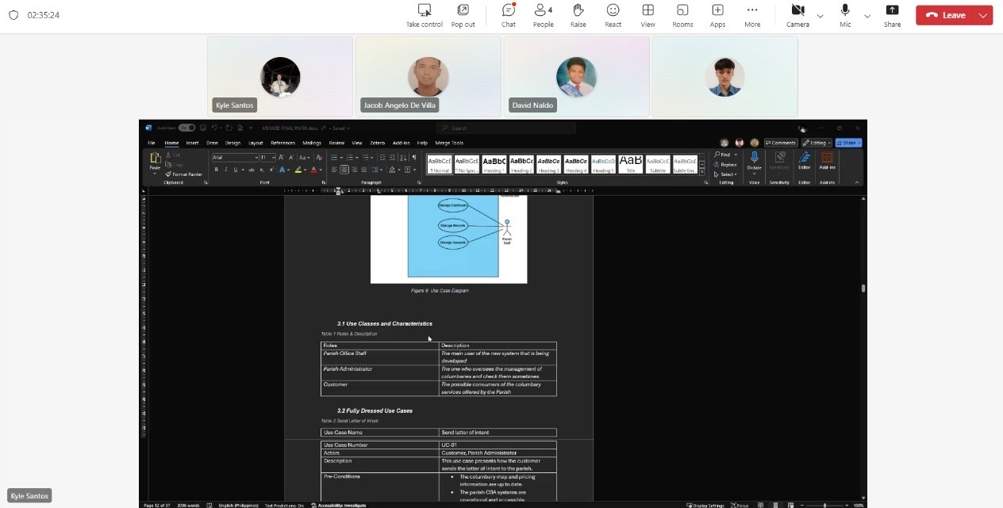

Figure 41: Final Meeting Before Finals Defense